FLYTRACKER CLIMBING ASSAY

The Flytracker program and associated files can be found at:

<https://github.com/brettbarbaro/Flytracker>

The Flytracker climbing assay measures Drosophila geotaxis using common equipment and techniques. No special methods or anaesthetization of the flies is necessary.

Here are the steps of the assay:

1. Make all necessary adjustments to equipment - height of camera and rack, background, etc. Turn off extraneous lights.
2. Place the rack with the original well-labeled vials on the platform.
3. Start recording.
4. Replace the original vial rack with the experimental rack.
5. Tap the flies to the bottoms of the tubes, and remove your hands quickly. The vials should be completely still and the scene static except for the flies by the 1 second mark.
6. Allow the flies to climb for approximately 5 seconds. (At least 3 seconds - only the positions at 2 and 3 seconds are used for calculating the speed. The flies on the ends need to be allowed to reach the top in order for Flytracker to properly detect the positions of the vials.)
7. Repeat from step 5 about 20 times. More is better for statistics.
8. Stop recording, and analyze results.

There are a number of things to consider when performing the assay:

1. synthetic plugs - Use synthetic plugs with flat bottoms.
2. integration with longevity assay - The way I performed the experiments, I generally did a climbing assay every time I passed the flies. I would start with equal numbers of flies, and pass them 2-3 times per week. Every time I passed them, I did a climbing assay and counted the number of dead flies in the vial. For consistency I performed these at the same time every day, usually in the afternoon.
3. number of flies - for the most accurate results, it's best to have equal numbers of flies in each vial. Somewhere between 10 and 30.
4. controls on outside - the first and last vials should always contain controls. A large number of flies that climb more or less normally and quickly from the bottom to the top. Flytracker identifies the locations of the vials by automatically detecting the outside vials.
5. white background - paper, diffuser - it's best for the background to be entirely white, and for the light to be somewhat diffuse and evenly distributed.
6. glare - reflections on the surfaces of the vials and racks, and any odd shadows or light spots that appear during the video will throw off Flytracker's ability to detect the flies. It's best if the only light source is behind the flies.
7. first shot - The first shot of any video should identify the vials. I usually placed the original vials, well-marked, in the correct order in a separate rack. It was extremely important to keep track of which flies are which, because the vials I used for the climbing assay were unmarked.
8. plastic vials get dirty - This is not really a problem for the most part - I used the same vials maybe 50 times. The important thing is that the vials are all the same. Brand new plastic vials tend to have some static electricity, which can alter the climbing. This can be fixed to some extent by running them under water and letting them dry. However, don't replace just one tube - make sure all tubes used are as similar as possible.
9. be consistent - the conditions that the flies are running under should be consistent for each assay. Important considerations are temperature, time of day, light, air quality, noise, location, etc. It's best to let the flies acclimate to the environment for a bit (maybe 15 minutes, or longer if the vials are cold and need to adjust to room temperature).

ANALYSIS

To analyze the video you created, first copy it onto a computer with MATLAB installed. Make sure that the Flytracker program is in the MATLAB path.

1. Create a new folder, and put all of the videos you want to analyze in it.
2. Go to MATLAB.
3. Navigate so that the "Current Folder" is your new folder with the video(s) in it.
4. Type "flytracker" at the command prompt.
5. Follow instructions.

You should see the following:

Welcome to Flytracker!

Flytracker will analyze all .avi and .mov files in the current folder.

For best results, vials should be evenly spaced

with healthy control flies in the outside vials.

How many vials are being compared?

Enter the number of vials. Then you should see:

Do you want to see the details? (0=no, 1=yes)

If you enter 0, Flytracker will save, for each video in the folder:

1. A .jpg of the first frame.
2. A .csv file for every segment showing the positions of all detected flies in that segment. (Flies are detected in every 5th frame [every 1/6 second]. Odd rows are x values, even are y; each pair of rows represents a single frame; each column represents a different detection event)
3. A .csv file called "VIDEONAME_FLYTRACKERVERSION_AVGHEIGHTS" for each video in the folder.

In addition, Flytracker will save:

1. The results will be saved in a .csv file in the folder, with the name "FOLDERNAME_OUTPUT.csv". This file can be opened and read in Excel.

If you enter 1, Flytracker will also save, for each segment of each video:

1. A .jpg of the first frame of each segment.
2. A .jpg of the background that was subtracted from all frames to detect flies. (Note - this is just the inverse of the final image in the segment. I used to take an average of several frames across the segment, but it took a long time. I empirically found that this method works just as well.)
3. A .jpg of the flies detected at each second, marked in red.
4. A .jpg "CHECKFRAME" to quickly check if the vial detection worked properly. (This is the same as the image from second 2 in step #6.)

Open FOLDERNAME_OUTPUT.csv in Excel, and it should look like the following:

|  |  |  |  |  |  |  |  |  |  |  |  |  |  |  |  |  |
| --- | --- | --- | --- | --- | --- | --- | --- | --- | --- | --- | --- | --- | --- | --- | --- | --- |
| VIDEO | VIAL | AVG SPEED | SEM SPEED | STD SPEED | AVG # FLIES | STD FLIES | AVG STD FLIES | MAX MAX FLIES | AVG MAX FLIES | STD MAX FLIES | DURATION | TOTAL SEGMENTS | EXCLUDED SEGMENTS | |  |  |
| CIMG1693.AVI | 1 | 0.078747 | 0.0037791 | 0.017725 | 40.8492 | 4.5665 | 8.2965 | 62 | 51.5909 | 6.794 | 961.1952 | 40 | 1 | 2 | 3 | 4 |
| CIMG1693.AVI | 2 | 0.086277 | 0.0048758 | 0.022869 | 40.1519 | 5.0839 | 7.7467 | 61 | 49.6364 | 6.3886 | 961.1952 | 40 | 1 | 2 | 3 | 4 |
| CIMG1693.AVI | 3 | 0.12139 | 0.010587 | 0.049659 | 33.5782 | 2.2465 | 6.0195 | 44 | 40.6364 | 2.4013 | 961.1952 | 40 | 1 | 2 | 3 | 4 |
| CIMG1693.AVI | 4 | 0.14366 | 0.0081466 | 0.038211 | 18.0631 | 2.2052 | 3.5612 | 26 | 22.6818 | 2.0791 | 961.1952 | 40 | 1 | 2 | 3 | 4 |
| CIMG1693.AVI | 5 | 0.15449 | 0.0087231 | 0.040915 | 14.2761 | 1.3064 | 3.173 | 20 | 18.2273 | 1.066 | 961.1952 | 40 | 1 | 2 | 3 | 4 |
| CIMG1693.AVI | 6 | 0.075191 | 0.0047434 | 0.022248 | 34.2417 | 3.4261 | 6.735 | 52 | 42.5455 | 4.3614 | 961.1952 | 40 | 1 | 2 | 3 | 4 |

SPEED = the average height of the flies in the vial at second 3, minus that at second 2, as a fraction of the climbable vial height. Climbable vial height is determined separately for each segment, and is taken to be the highest point that any fly is detected in the segment. For this reason it is important to let some flies get all the way to the top for each segment.

VIDEO = name of the video file for the results on that row.

VIAL = the vial number for the results on that row (1 = leftmost).

AVG SPEED = the average SPEED over all INCLUDED segments.

SEM SPEED = the Standard Error of the Mean of "AVG SPEED"

STD SPEED = the Standard Deviation of "AVG SPEED"

AVG # FLIES = the average number of flies detected in the vial

STD FLIES = the Standard Deviation of "AVG # FLIES"

AVG STD FLIES =

MAX MAX FLIES = the maximum number of flies ever detected in the vial

AVG MAX FLIES = the average of the maximum flies over all segments

DURATION = duration of the video

TOTAL SEGMENTS = the total number of segments detected in the video

EXCLUDED SEGMENTS = segments that were automatically excluded from the analysis.

You might want to show how the files climbed over a longer period of time. For example:

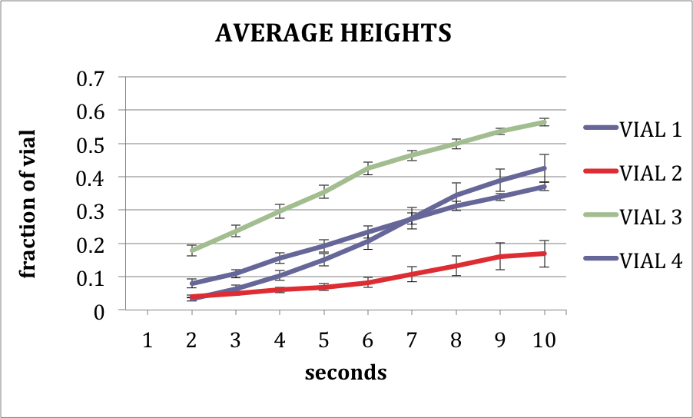

In this case, use the "AVGHEIGHTS" file data, and paste it into one of the templates I've provided. There are two templates, one for 4 vials, one for 6 vials. Feel free to edit them as you wish.

The templates will accommodate up to 30 seconds of climbing data. If none of the segments are longer than 30 seconds, then you should be able to open the "AVGHEIGHTS" file and Ctrl-A to "select all", then copy and paste. If there are segments longer than 30 seconds, you should select the first 32 rows, and copy and paste them.

The AVGHEIGHTS data should be pasted into cell that says "PASTE AVGHEIGHTS DATA HERE (UP TO FIRST 32 LINES)", which at the time of this writing was cell A6 of the template.

The template will generate charts automatically, including average height per second and average speed. P-values will also be calculated for the average speeds. The result will look like this:

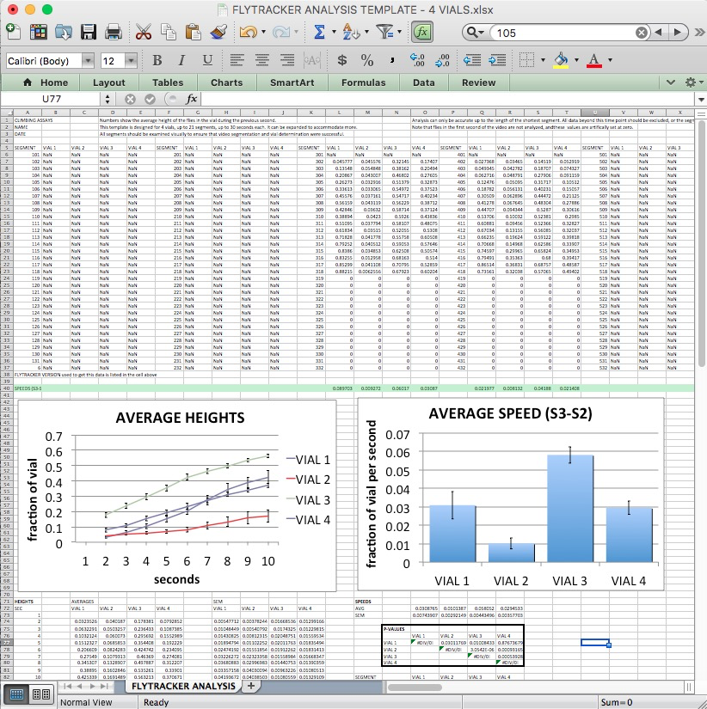

Limitations are that currently the templates will only process up to the first 20 or so segments, and up to the first 30 seconds. These are not limitations of the Flytracker program, and the templates can be expanded to accommodate more data if desired. I have found that the existing limitations have been adequate for my purposes.